Week 5_DQ

Samrat Jung Shahi
Westcliff University
PRG:200
Professor: Ashok Basnet
June 7, 2026
Week 5_DQ

Github Link

Figure 1: Question 1- Bank Account Manager

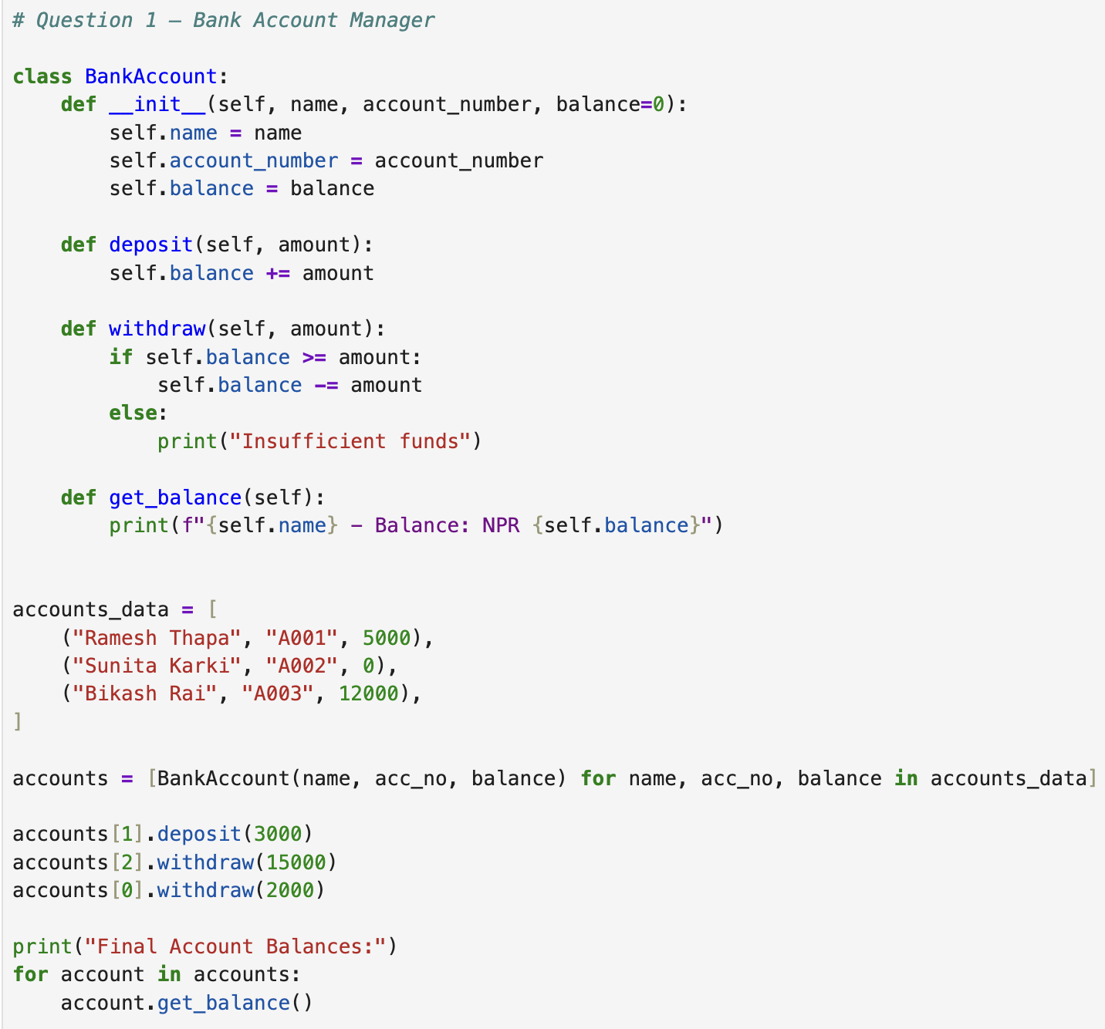
Figure 2: Question 1- Bank Account Manager and its Output
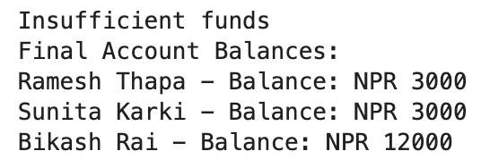

Figure 3: Question 2- Study Report Card
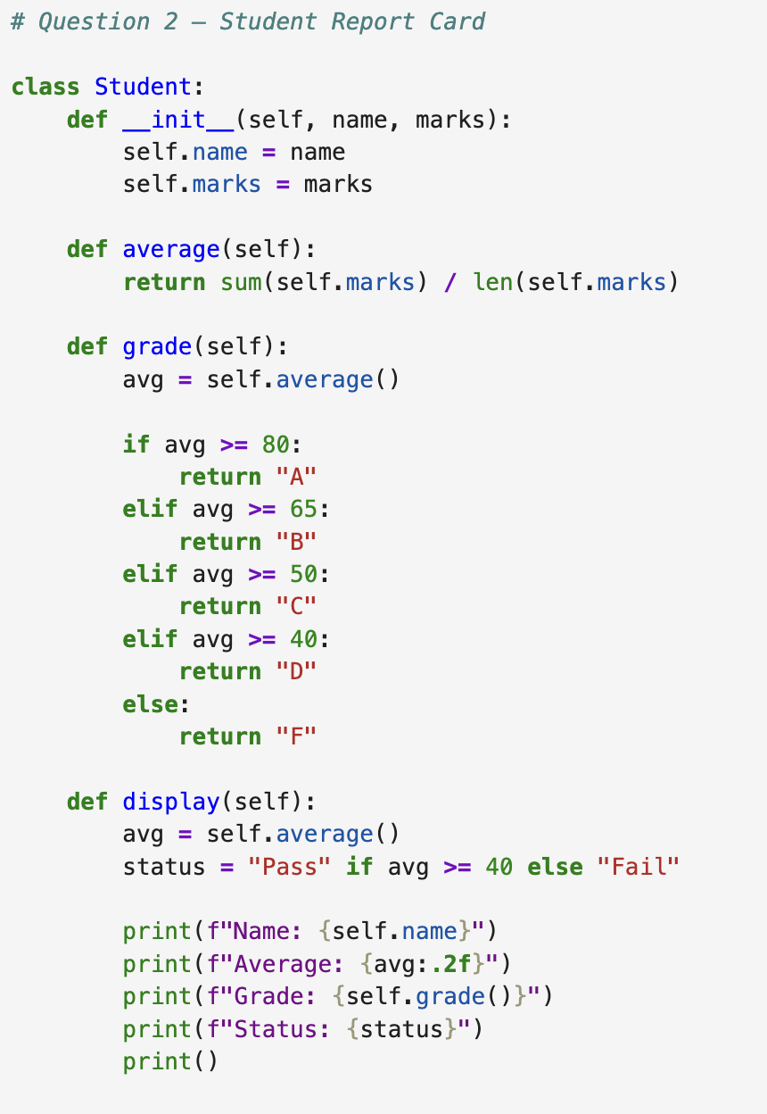

Figure 3: Question 2- Study Report Card and its Output
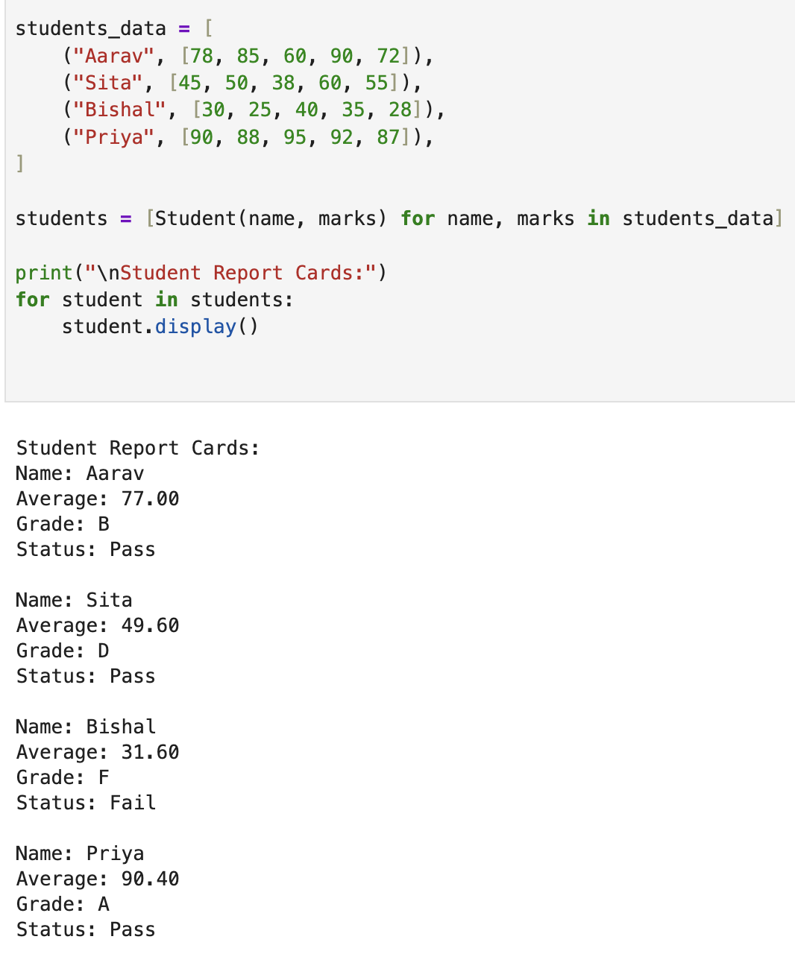
Figure 4: Question 3- Food Delivery App
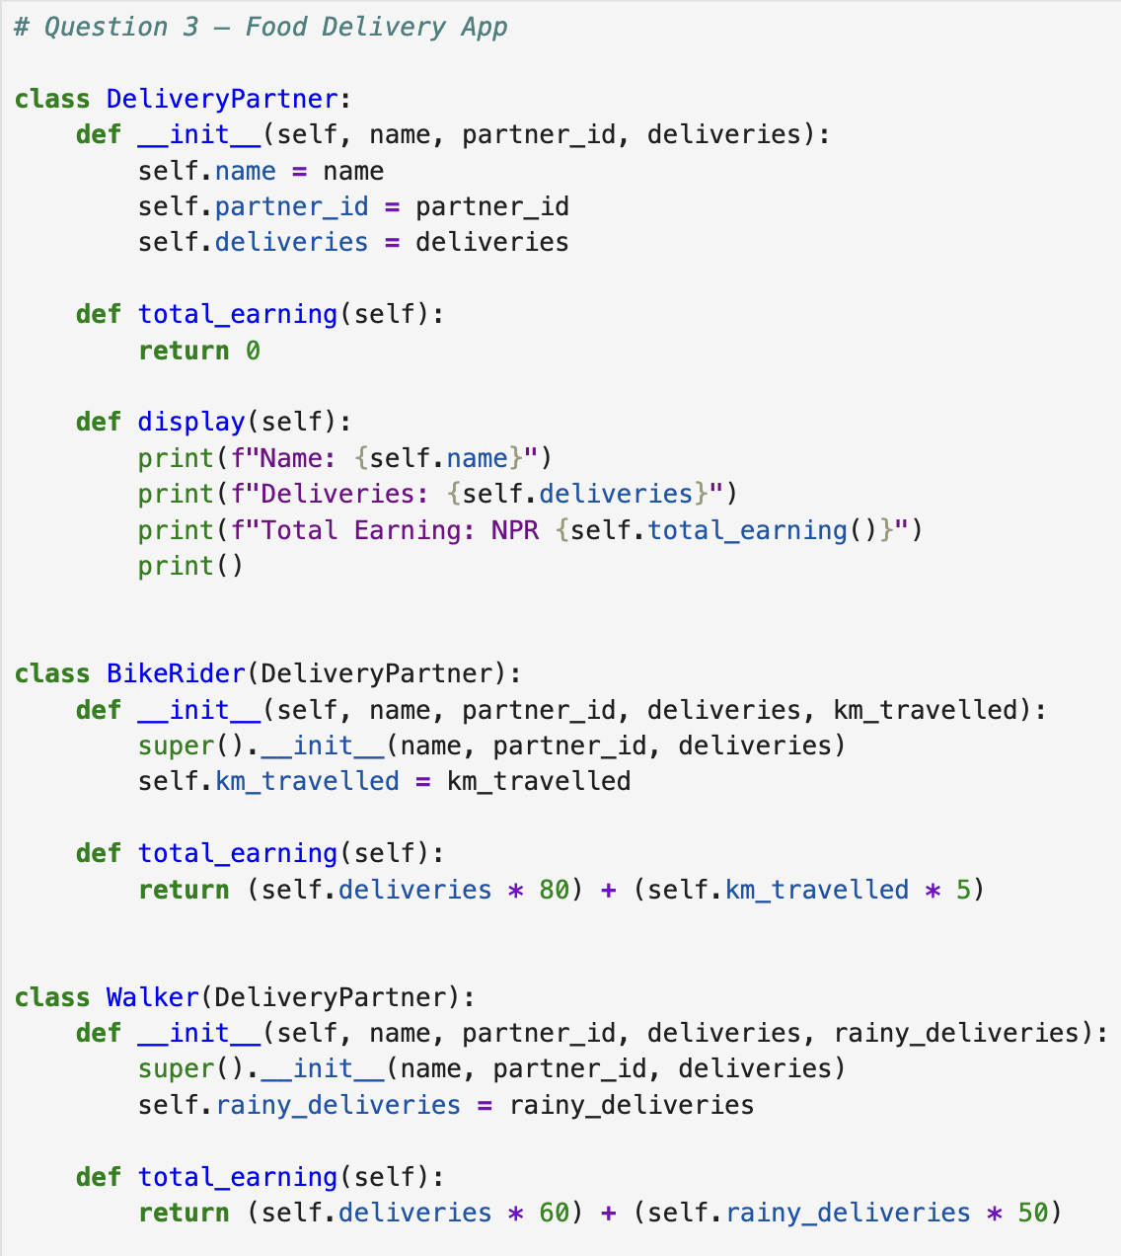
Figure 5: Question 3- Food Delivery App and its output
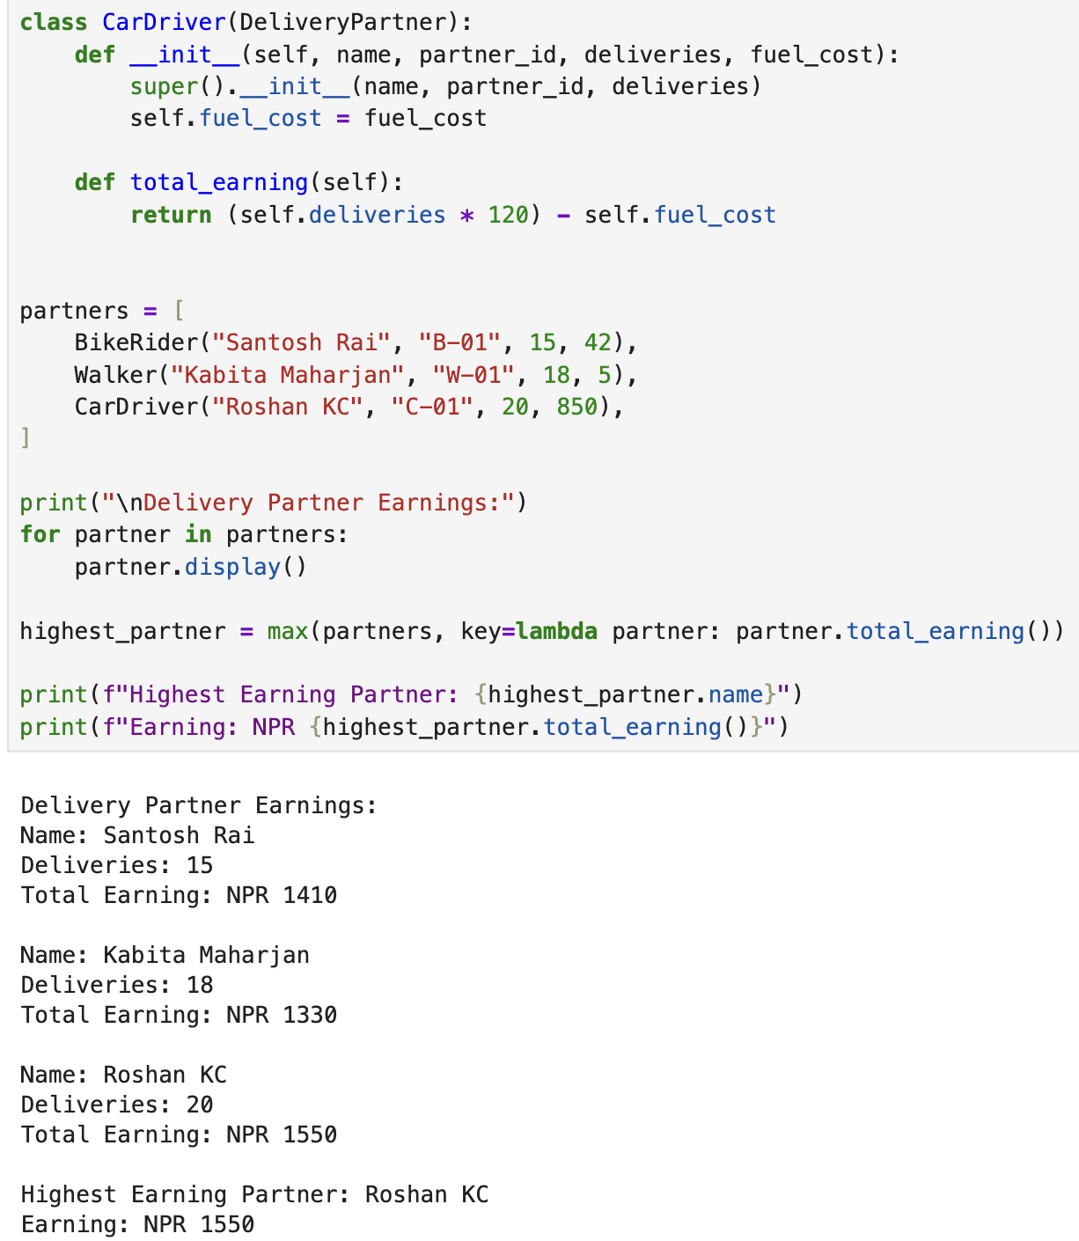
Figure 6: Question 4- Bus Ticket Booking
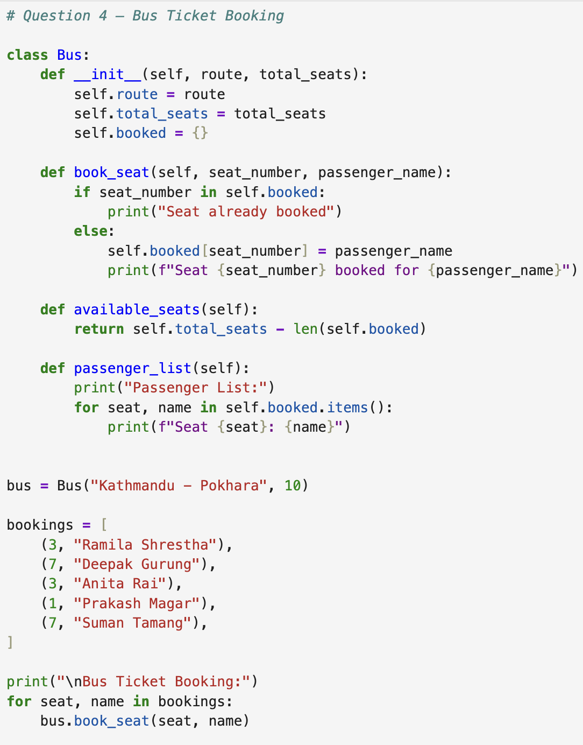

Figure 7: Question 4- Bus Ticket Booking and its Output
